User Guide

1. Introduction

This project, the Reinforcement Learning Model for Games, is meant to display the interesting applications of machine learning to those that are unfamiliar with the concept.

Machine learning is the study of computer algorithms that automatically improve through growing experience and understanding. It essentially allows computers to learn in a way similar to humans, by recognizing patterns and looking back on past experiences. Instead of being taught directly by a computer programmer, artificial intelligence (AI) taught through machine learning will teach itself through experiences.

This project utilizes reinforcement learning, which is a type of machine learning that focuses on an AI agent’s interactions in an environment. They make actions, see the rewards they receive for those actions, and build an understanding of what will happen when they do certain things at certain times. Their learning is “reinforced” by the rewards they receive for certain actions.

For this project, an AI has been taught to play multiple board games against a human opponent. You can boot up the project and challenge the AI to games of Tic-Tac-Toe, Connect Four, and Dots and Boxes. While playing against the AI, you can see their behavior. The AI has been taught purely through playing the games, and learned the rules and the best courses of action through trial and error. It was never told the rules or what to do.

Play a few games and see how the AI behaves. We hope that it will spark your interest in machine learning, AI development, and computer science in general.

1. Install

See installation guide for instructions on how to install and set up the project.

It can be found in the doc folder of the project’s GitHub: <https://github.com/mammalwithashell/WJNKCW/tree/main/doc>

1. Main Menu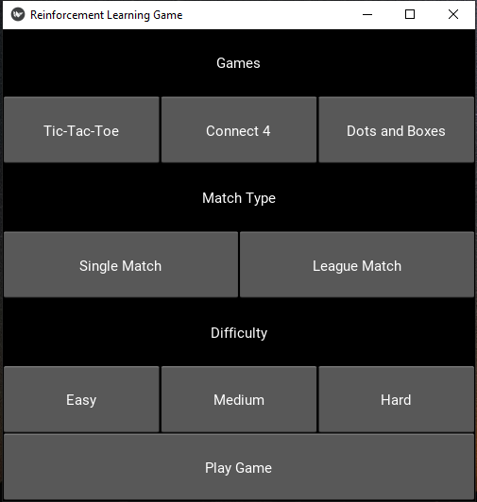
   1. Games: Select which game you would like to play. Instructions for each game provided later in the document.
   2. Match Type: Select which match format you would like to play. Explanations for both formats provided later in the document.
   3. Difficulty: Select the level of difficulty for the artificial intelligence you will be playing against.
      1. Easy: The easy AI agent is tuned to play against a player who is unfamiliar with each game or just learned the rules.
      2. Medium: The medium AI agent is tuned to play against a player who is familiar with each game’s rules.
      3. Hard: The hard AI agent is tuned to be difficult for a player who is familiar with each game’s rules.
   4. When ready to begin playing, select Play Game.
2. Games
   1. Tic-Tac-Toe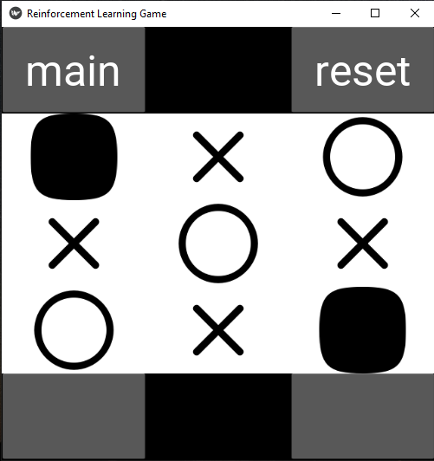

In Tic-Tac-Toe, each player tries to get three of their own symbols (Xs or Os) in a row, either horizontal, vertical, or diagonal. Each player takes turns going. Select where you would like to place your piece by clicking the desired spot. The AI opponent will go automatically and it will return to your turn.

* 1. Connect 4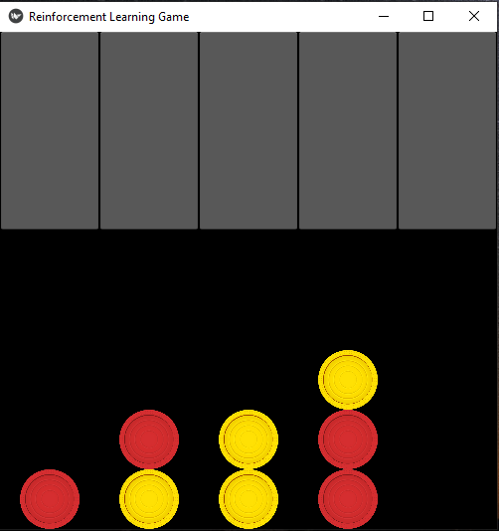

In Connect 4, each player takes turns trying to line up four of their colored pieces in a row, either horizontally, vertically, or diagonally. The pieces are placed by selecting the grey boxes at the top to pick a column. Then, the piece will drop down to the lowest open slot in that column to take its place. The AI will automatically select its place and then it will return to your turn.

* 1. Dots and Boxes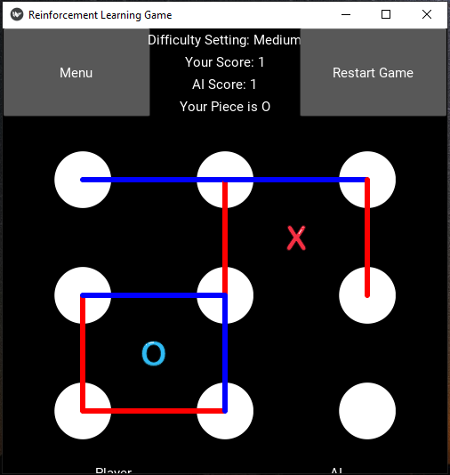

In Dots and Boxes, each player tries to create as many complete boxes as possible, drawing them one line at a time. Players take turns drawing lines between the white dots, and whoever draws the last line to complete a box of four sides receives a point. In addition, upon completing a box, the player will be able to immediately take another turn before their opponent. To draw a line with this game, click and drag between white dots.

1. Match Type
   1. Single Match: With this match format, players will get to play a single match of their selected game against the AI opponent. There will be no continuation afterwards, and the AI will simply try to win the game.
   2. League Match: In this match format, the player and AI will bet against each other using chips. They will bet before each match of a game, and both will have the option to quit playing. This match format is designed to show the AI’s risk-avoiding and reward-seeking behaviors, especially in a series of long-term decisions.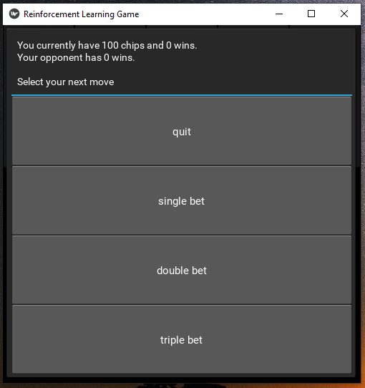

The betting screen allows players to quit or make a single, double, or triple bet. The larger bets entail betting progressively larger numbers of chips on the following match.

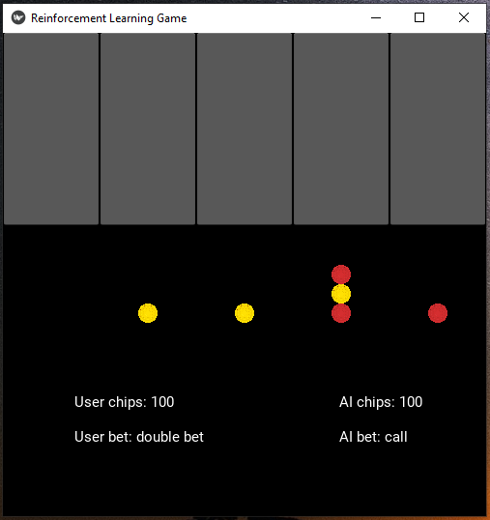

During a league match, players can see the selected bet, the AI’s bet, and the number of chips the player and AI have. Otherwise, each game functions normally, as described in the games section of this guide.